To ensure that your announcement is clear and easy to read, we recommend the following guidelines:

Use TBS Logos, colors, and fonts as found in:

TBS Style Guide at:

tiny.cc/tbsstyleguide

1. Use a minimum font size of 28 pt.

This is 28 pt

This is 36 pt

This is 48 pt

This is 72 pt

1. Use TBS fonts:

GOTHAM

GOTHAM MEDIUM

GOTHAM BOLD

GOTHAM NARROW

&

for “TBS” or “**Temple Beth Shalom**”, use Trajan Pro or **Trajan Pro Bold**

1. Use only graphics that have resolution of 300 dpi or greater.
2. Use the provided Powerpoint template (6x9DisplayTemplate.potx) to compose your announcement using fonts recommended above, and graphics to fit within the pre-formatted 16 x 9 page layout.
   1. Use “Save As” to save your completed announcement template as a JPG.
      1. (Your saved JPG will have a “.jpg” file extension.)
3. Prepare file for submission to Communications
   1. With Powerpoint 2016 or greater, select File -> Save As.
   2. Select a destination location
   3. Enter file name
   4. Change “Save as type:” to “JPEG File Interchange Format
   5. Select Tools (near the save button) -> Compress Pictures
   6. Select High fidelity and press OK
   7. Press Save

The logo graphics on the following pages are provided for your convenience. These logos will display clearly when included in your display announcement.

**For details on TBS approved logos, fonts, and color standards please refer to the Temple Beth Shalom Logo Branding guide at:** [**tiny.cc/tbsstyleguide**](http://tiny.cc/tbsstyleguide)

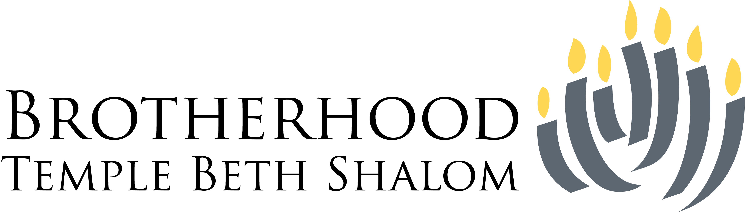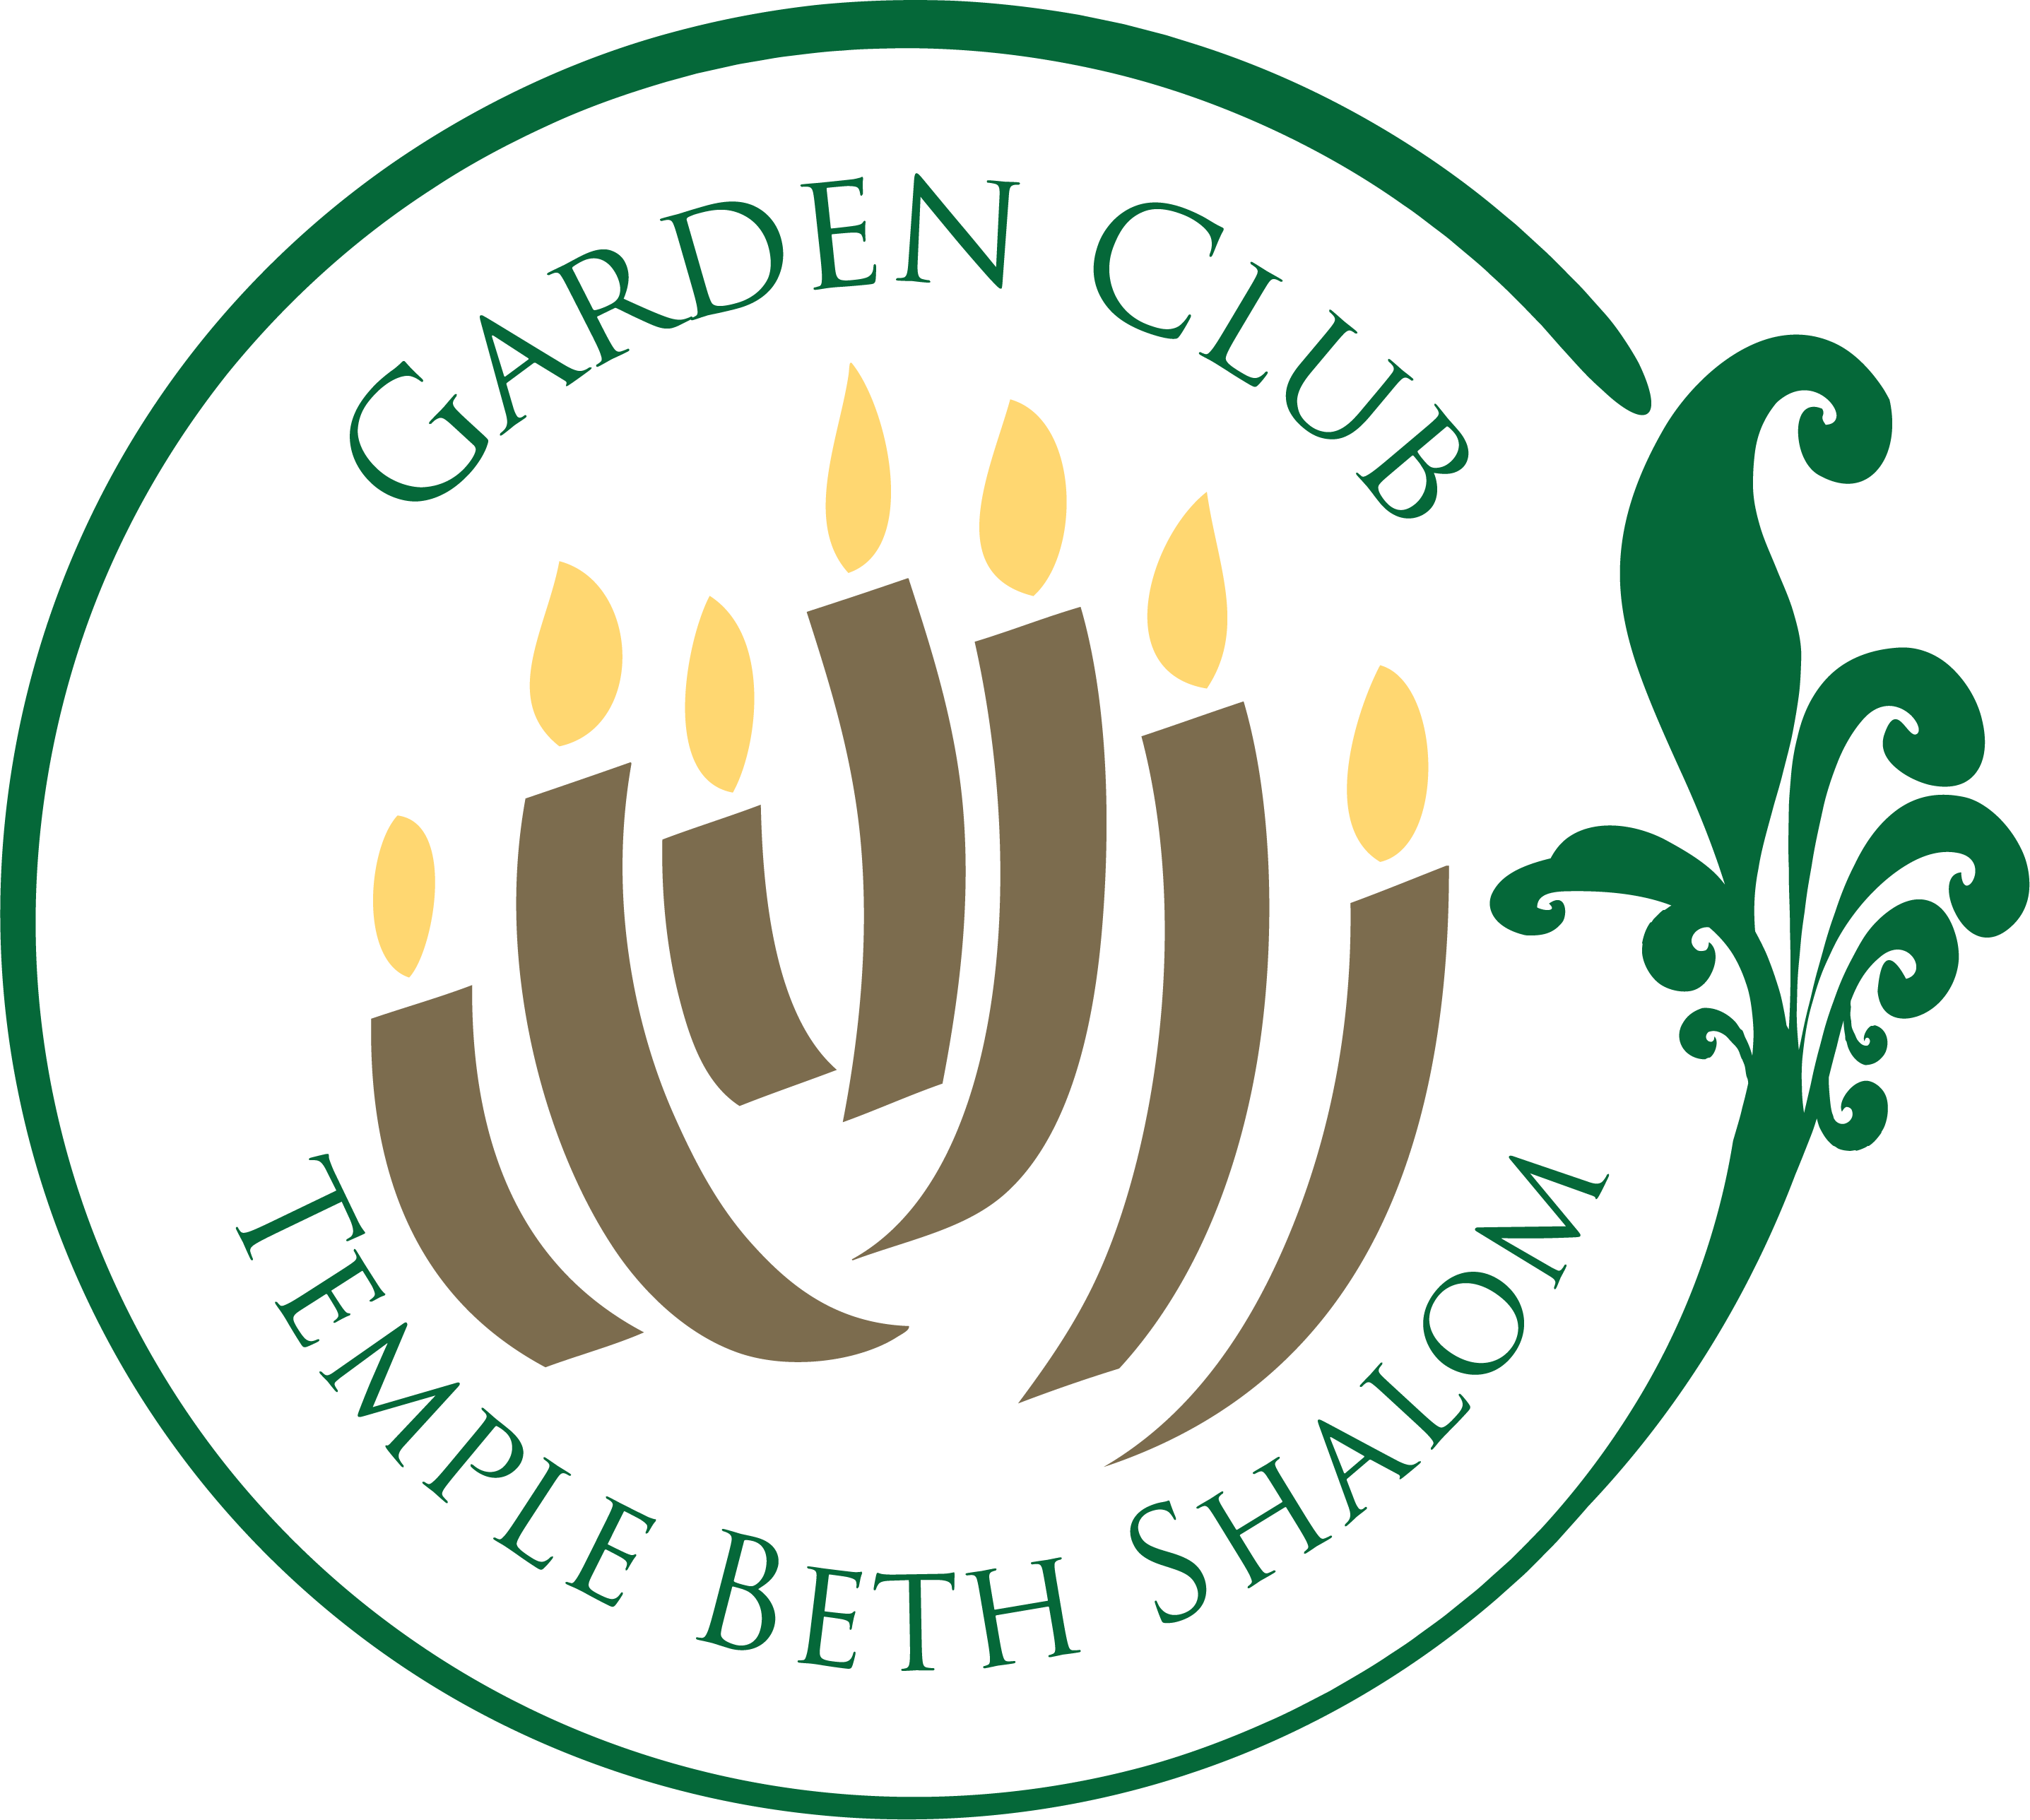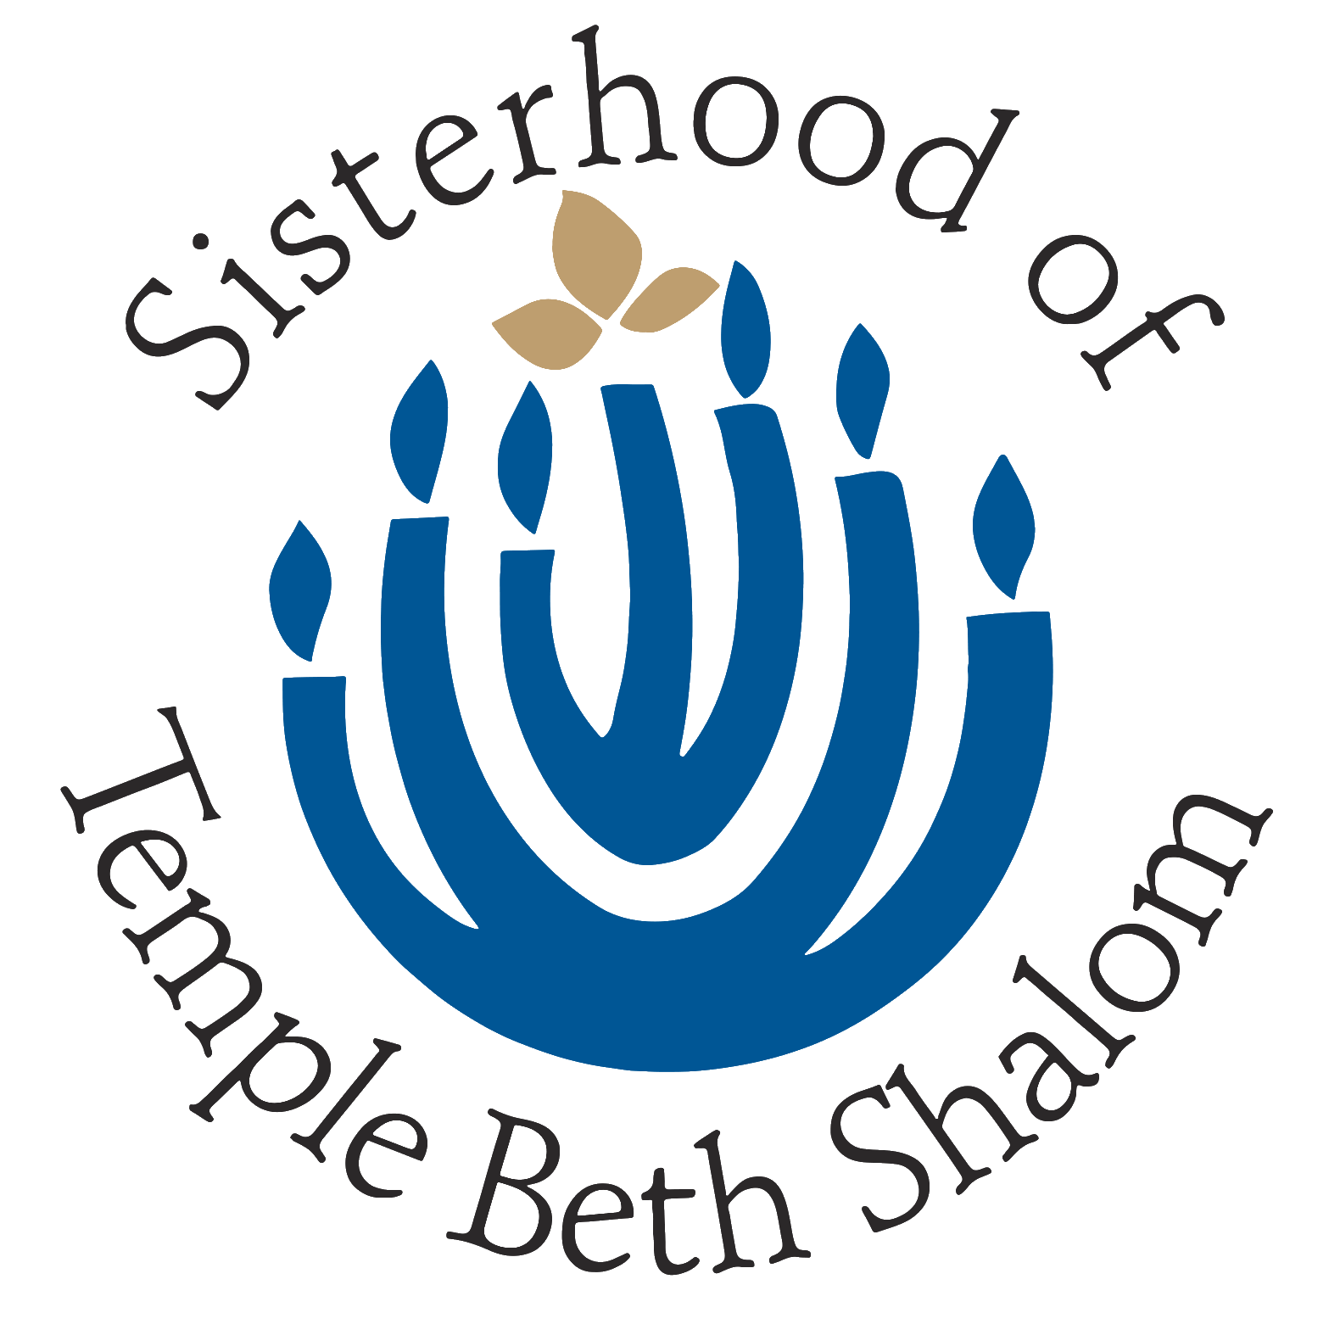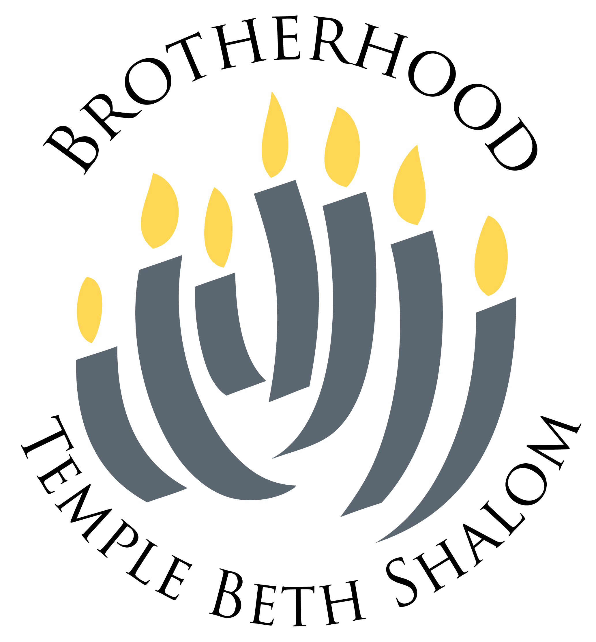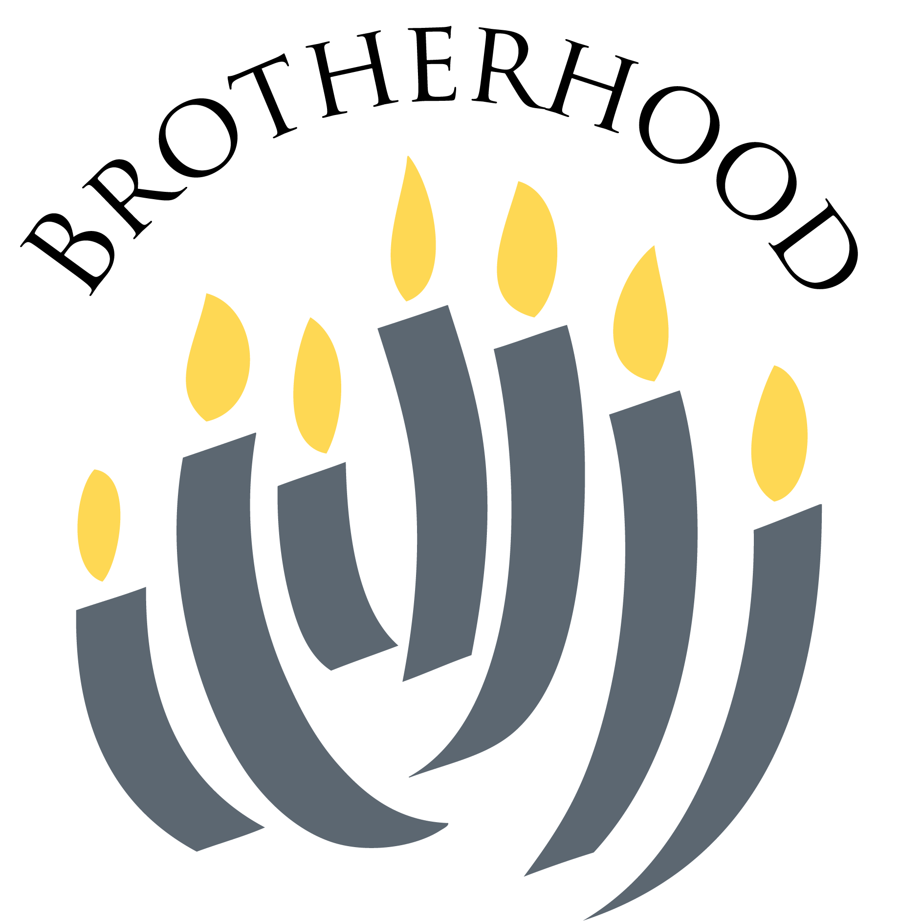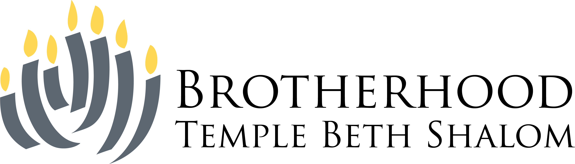

Use graphics with a minimum of 300 DPI

All logos are fully scalable, on transparent backgrounds.

You may place them in your announcements as appropriate.

Use graphics with a minimum of 300 DPI

All logos are fully scalable, on transparent backgrounds.

You may place them in your announcements as appropriate.